**4A.Prime Number**

**Code:**

<html>

    <head>

        <title>Prime number</title>

    </head>

    <body>

        <script>

            let count=0

            let i,j

            for(j=2;j<=100;j++)

            {

            for(i=1;i<=j;i++)

             {

                  if(j%i==0)

                  count++

            }

            if(count==2)

                document.write("<br>"+j)

            count=0

            }

        </script>

    </body>

**Output:**

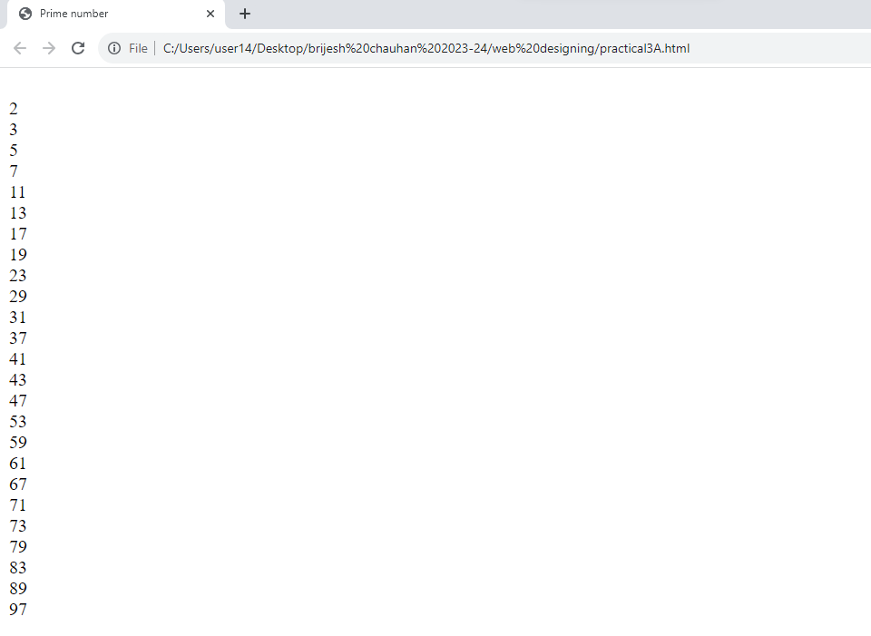

**4B.Designing Calculator**

**Code:HTML**

!DOCTYPE html>

<html lang="en">

<head>

   <link rel="stylesheet" href="style.css">

   <title>Calulator</title>

</head>

<body>

   <div class="main">

      <input type="text" id = 'res'>

      <div class="btn">

         <input type="button" value = 'C' onclick = "Clear()">

         <input type="button" value = '%' onclick = "Solve('%')">

         <input type="button" value = '←' onclick ="Back('←')">

         <input type="button" value = '/' onclick = "Solve('/')">

         <br>

         <input type="button" value = '7' onclick = "Solve('7')">

         <input type="button" value = '8' onclick = "Solve('8')">

         <input type="button" value = '9' onclick = "Solve('9')">

         <input type="button" value = 'x' onclick = "Solve('*')">

         <br>

         <input type="button" value = '4' onclick = "Solve('4')">

         <input type="button" value = '5' onclick = "Solve('5')">

         <input type="button" value = '6' onclick = "Solve('6')">

         <input type="button" value = '-' onclick = "Solve('-')">

         <br>

         <input type="button" value = '1' onclick = "Solve('1')">

         <input type="button" value = '2' onclick = "Solve('2')">

         <input type="button" value = '3' onclick = "Solve('3')">

         <input type="button" value = '+' onclick = "Solve('+')">

         <br>

         <input type="button" value = '00'onclick = "Solve('00')">

         <input type="button" value = '0' onclick = "Solve('0')">

         <input type="button" value = '.' onclick = "Solve('.')">

         <input type="button" value = '=' onclick = "Result()">

      </div>

   </div>

   <script src = 'Calc.js' ></script>

</body>

</html>

**Code:CSS**

*{

  padding: 0;

  margin: 0;

  font-family: 'poppins', sans-serif;

}

body{

  background-color: #495250;

  display: grid;

  height: 100vh;

  place-items: center;

}

.main{

  width: 400px;

  height: 450px;

  background-color: white;

  position: absolute;

  border: 5px solid black;

  border-radius: 6px;

}

.main input[type='text'] {

  width: 88%;

  position: relative;

  height: 80px;

  top: 5px;

  text-align: right;

  padding: 3px 6px;

  outline: none;

  font-size: 40px;

  border: 5px solid black;

  display: flex;

  margin: auto;

  border-radius: 6px;

  color: black;

}

.btn input[type='button']{

  width:90px;

  padding: 2px;

  margin: 2px 0px;

  position: relative;

  left: 13px;

  top: 20px;

  height: 60px;

  cursor: pointer;

  font-size: 18px;

  transition: 0.5s;

  background-color: #495250;

  border-radius: 6px;

  color: white;

}

.btn input[type='button']:hover{

  background-color: black;

  color: white;

}

**Code: JavaScript**

function Solve(val) {

    var v = document.getElementById('res');

    v.value += val;

 }

 function Result() {

    var num1 = document.getElementById('res').value;

    var num2 = eval(num1);

    document.getElementById('res').value = num2;

 }

 function Clear() {

    var inp = document.getElementById('res');

    inp.value = '';

 }

 function Back() {

    var ev = document.getElementById('res');

    ev.value = ev.value.slice(0,-1);

 }

**Output:**

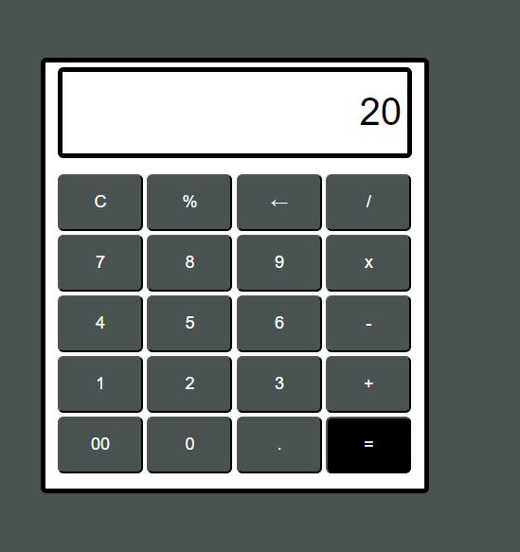

**4C.Calculator using text boxes**

**Code:HTML**

<!DOCTYPE html>

<html lang="en">

<head>

    <meta charset="UTF-8">

    <meta name="viewport" content="width=device-width, initial-scale=1.0">

    <link rel="stylesheet" href="styles.css">

    <title>Fibonacci Calculator</title>

</head>

<body>

    <div class="calculator">

        <h1>Fibonacci Series Calculator</h1>

        <label for="inputNumber">Enter a number:</label>

        <input type="number" id="inputNumber" placeholder="Enter a number">

        <button onclick="calculateFibonacci()">Calculate</button>

        <div id="fibonacciResult"></div>

    </div>

    <script src="script.js"></script>

</body>

</html>

**Code :CSS**

body {

    font-family: Arial, sans-serif;

    background-color: #f0f0f0;

    display: flex;

    justify-content: center;

    align-items: center;

    height: 100vh;

    margin: 0;

}

.calculator {

    background-color: #fff;

    border-radius: 10px;

    box-shadow: 0px 0px 10px rgba(0, 0, 0, 0.2);

    padding: 20px;

    text-align: center;

    width: 300px;

}

h1 {

    font-size: 24px;

    margin-bottom: 10px;

}

label {

    font-size: 16px;

    margin-bottom: 5px;

}

input[type="number"] {

    width: 100%;

    padding: 10px;

    font-size: 18px;

    margin-bottom: 10px;

}

button {

    padding: 10px 20px;

    font-size: 18px;

    background-color: #007BFF;

    color: white;

    border: none;

    cursor: pointer;

}

button:hover {

    background-color: #0056b3;

}

#fibonacciResult {

    font-size: 18px;

    margin-top: 10px;

}body {

    font-family: Arial, sans-serif;

    background-color: #f0f0f0;

    display: flex;

    justify-content: center;

    align-items: center;

    height: 100vh;

    margin: 0;

}

.calculator {

    background-color: #fff;

    border-radius: 10px;

    box-shadow: 0px 0px 10px rgba(0, 0, 0, 0.2);

    padding: 20px;

    text-align: center;

    width: 300px;

}

h1 {

    font-size: 24px;

    margin-bottom: 10px;

}

label {

    font-size: 16px;

    margin-bottom: 5px;

}

input[type="number"] {

    width: 100%;

    padding: 10px;

    font-size: 18px;

    margin-bottom: 10px;

}

button {

    padding: 10px 20px;

    font-size: 18px;

    background-color: #007BFF;

    color: white;

    border: none;

    cursor: pointer;

}

button:hover {

    background-color: #0056b3;

}

#fibonacciResult {

    font-size: 18px;

    margin-top: 10px;

}

**Code :Javascript**

function calculateFibonacci() {

    const inputNumber = parseInt(document.getElementById("inputNumber").value);

    if (isNaN(inputNumber) || inputNumber < 0) {

        document.getElementById("fibonacciResult").textContent = "Please enter a non-negative number.";

        return;

    }

    const fibonacciArray = [0, 1];

    for (let i = 2; i <= inputNumber; i++) {

        const nextFibonacci = fibonacciArray[i - 1] + fibonacciArray[i - 2];

        fibonacciArray.push(nextFibonacci);

    }

    document.getElementById("fibonacciResult").textContent = `Fibonacci Series up to ${inputNumber}: ${fibonacciArray.join(', ')}`;

}

**Output :**

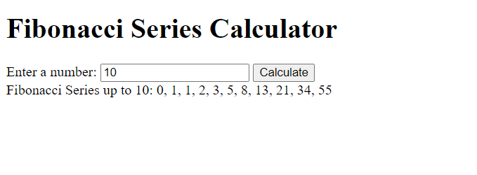

**4D.Even Odd**

**Code : HTML**

<!DOCTYPE html>

<html lang="en">

<head>

    <meta charset="UTF-8">

    <meta name="viewport" content="width=device-width, initial-scale=1.0">

    <link rel="stylesheet" href="styles.css">

    <title>Even Odd Checker</title>

</head>

<body>

    <div class="even-odd-checker">

        <h1>Even Odd Number Checker</h1>

        <label for="number">Enter a number:</label>

        <input type="number" id="number" placeholder="Enter a number">

        <button onclick="checkEvenOdd()">Check</button>

        <div id="result"></div>

    </div>

    <script src="script.js"></script>

</body>

</html>

**Code :CSS**

body {

    font-family: Arial, sans-serif;

    background-color: #f0f0f0;

    display: flex;

    justify-content: center;

    align-items: center;

    height: 100vh;

    margin: 0;

}

.even-odd-checker {

    background-color: #fff;

    border-radius: 10px;

    box-shadow: 0px 0px 10px rgba(0, 0, 0, 0.2);

    padding: 20px;

    text-align: center;

    width: 300px;

}

h1 {

    font-size: 24px;

    margin-bottom: 10px;

}

label {

    font-size: 16px;

    margin-bottom: 5px;

}

input[type="number"] {

    width: 100%;

    padding: 10px;

    font-size: 18px;

    margin-bottom: 10px;

}

button {

    padding: 10px 20px;

    font-size: 18px;

    background-color: #007BFF;

    color: white;

    border: none;

    cursor: pointer;

}

button:hover {

    background-color: #0056b3;

}

#result {

    font-size: 18px;

    margin-top: 10px;

}

**Code : Javascript**

function checkEvenOdd() {

    const number = parseInt(document.getElementById("number").value);

    if (isNaN(number)) {

        document.getElementById("result").textContent = "Please enter a valid number.";

    } else if (number % 2 === 0) {

        document.getElementById("result").textContent = `${number} is an even number.`;

    } else {

        document.getElementById("result").textContent = `${number} is an odd number.`;

    }

}

**Output :**

